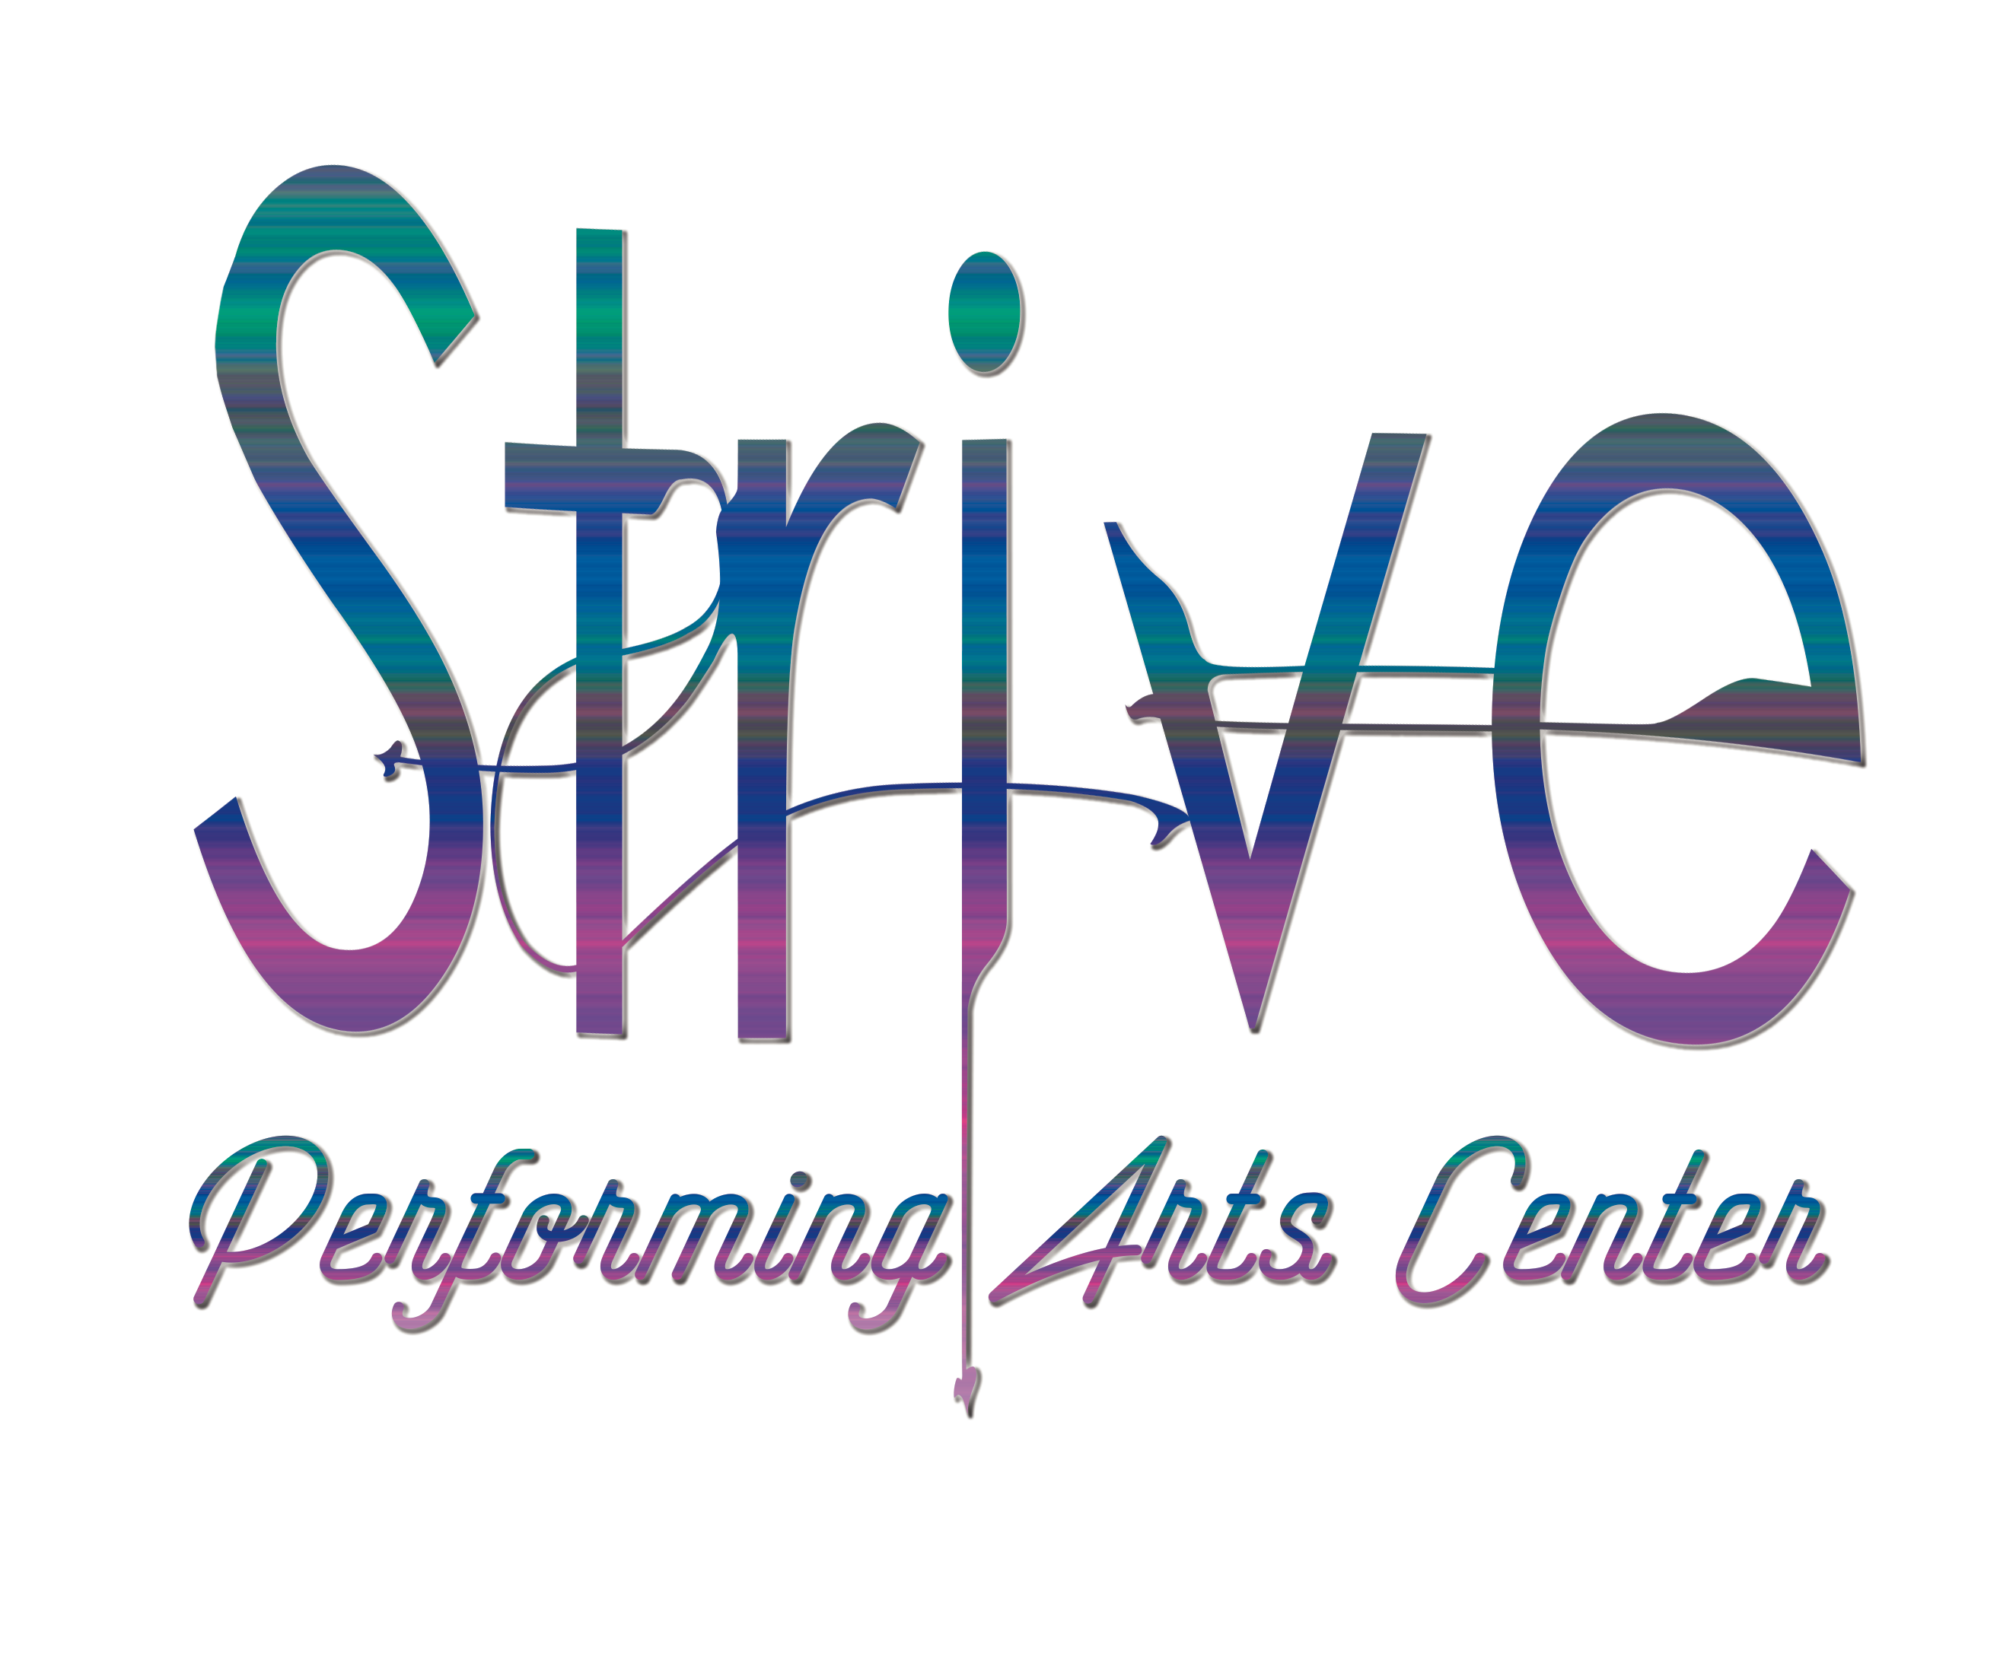
SUMMER ACADEMY REGISTRATION FORM
Please fill out and return all 3 pages of information

Parent A: ____________________________________________________________________________________

Cell:_____________________________Email:_______________________________________________________

Parent B:______________________________________________________________________________________

Cell:____________________________ Email:_______________________________________________________

Home Address:_______________________________________________________________________________

Additional Emergency Contact(s) Name and Number:

_________________________________________________________________________________________________

Student:______________________________________________________________________________________

DOB:________________________Age&Grade(of June 1st 2019)_________________________________

Allergies:_____________________________________________________________________________________

Important social, learning or physical info about the student:

List any and all Performing Arts Training:

________________________________________________________________________________________________

EARLY BIRD REGISTRATION DUE DATE MAY 14th
REGISTRATION DEADLINE JUNE 1st

PLEASE NOTE: Space is limited to 10-20 STUDENT MAXIMUM (depending on structure of class) Classes will be closed after this number is reached. In addition, any and all workshops and camps with less then our FIVE STUDENT MINIMUM will be CANCELLED. Reserve your spot today!

FILL OUT ALL INFORMATION BELOW WITH THE ENCLOSED TOTAL PAYMENT AND RETURN BY EMAIL or MAIL TO:
striveperformingartscenter@gmail.com or
406 Broad Avenue Belle Vernon, Pa 15012

Forms of Payment Accepted: Check, Cash and Credit Card. Credit Card Payment can be made over the phone or by providing us with the information below. Credit Card information will be securely disposed of after it is received.
Please Note: Credit Card Payment will incur a $5.00 processing fee

How Did You Hear About Us? _______________________________________________________

Age Group: ____________________________________________________________________________

Camps Enrolling In (refer to summer academy schedule and price list):

_________________________________________________________________________________________________

Workshops Enrolling In (refer to summer academy schedule and price list):

________________________________________________________________________________________________

Adult Classes Enrolling In (refer to summer academy schedule and price list):

____________________________________________________________________________________________

SUB-TOTAL: ______________________________________________________________________________

Special offers that apply: (refer to summer academy schedule and price list)

_________________________________________________________________________________________________

Credit Card Fee Processing $5

TOTAL Amount Enclosed: __________________________________________________________________

CREDIT CARD INFORMATION:

Name On Card:________________________________________________________

Card Number:_________________________________________________________

Security Code:_________________________________________________________

Expiration Date:_______________________________________________________

Street Address:__________________________________________________________________________

Signature: _____________________________________________________Date: _________________________

Legal Release and Policy Acceptance (please initial and sign)

___ I/we understand the Studio Policies ___ I/we understand my billing obligations
___ I/we understand the risks related to the arts ___ I/we understand my responsibilities for my property
___ I/we understand the dress code ___ I/we understand the schedule
___ I/we give media use rights permission ___ I/we understand the attendance policy

I /we understand that STRIVE Performing Arts Center does not grant refunds no matter the reason. In the event Strive Performing Arts Center cancels a refund will be processed.

________________________________________________________________________ ______________________________
Signature / Responsible Party Date

